**What Can VR Do for me?**

•

Assistance with transitional planning into the adult world

•

Vocational counseling and guidance to help you understand your capabilities

and develop compatible career goals

•

Information and referral to other valuable community services and agencies

•

Paid work experience through the Project Skills or Project Search for students

struggling with employment while attending high school

•

Assistive technology devices needed for post

-

secondary training or employment

•

Possible financial assistance for post

-

secondary training (requires financial

need)

•

On

-

the

-

job training leading to employment

•

Job placement services to include job development, job coaching and follow

-

up

for after high school or post

-

secondary training

•

Plus a lot more so ask to speak a Vocational Rehabilitation Counselor

!

Vocational Rehabilitation (VR) is a State/Federal program

that provides individualized vocational rehabilitation and

support services to help eligible individuals with disabilities

obtain and keep jobs compatible with their interests and

abilities.

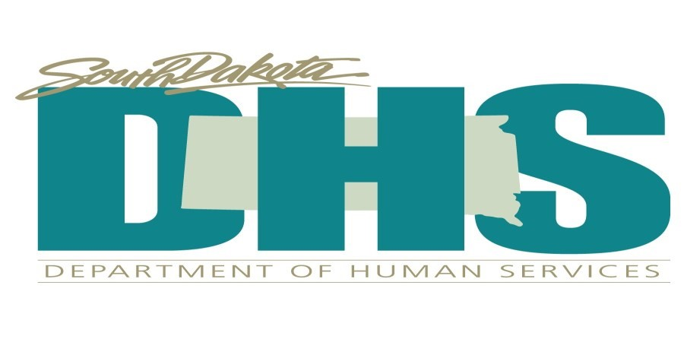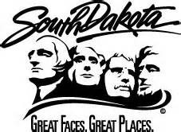

I’m interested! What are the eligibility requirements?

•

Must have a documented disability.

•

The disability must create a substantial impediment in terms of

employment outcome.

•

Must require services and be able to benefit from those services

to achieve an employment outcome.

Be sure to talk to the Vocational Rehabilitation

Counselor in your area for information specific to your needs!

