Transition Newsletter
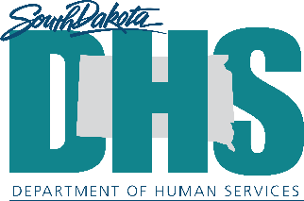

August 2026

Resource Highlight.

ASkJAN.org is a free website with info about disabilities, workplace accommodations, and employment.

Try out the “Situations & Solutions” tool which allows you to explore common workplace challenges and discover accommodation ideas that may help. You can search by disability, limitation, work-related task, or job situation to find real-world examples and practical solutions. This is a great way to learn how accommodations can help employees succeed and how to advocate for supports that meet individual needs.
askjan.org/sitsol/

This is informational only. DHS is neither supporting nor endorsing the website. Please determine for yourself if you wish to use it and proceed accordingly.

Understanding How Your Brain Works!

Everyone’s brain works in its own unique way. Learning more about your brain doesn’t define who you are, it just helps you understand how you learn, think, communicate, and tackle life.

Knowing what’s hard (and what helps!) can:
✅ Help you discover your strengths
✅ Make it easier to see challenges before they turn into bigger problems
✅ Help you speak up for the support or tools you need
✅ Boost your confidence by seeing strategies that actually work for you
This is just helpful info about your brain, NOT your identity.

Get to Know Yourself!
⭐ Write down things that feel hard for you
⭐ Talk with people you trust (family, teachers, counselors, doctors) who can help you learn more about what helps you.
⭐ Write in your own words how you learn best and what gets tricky

You’re more than the things that are hard so highlight your strengths!
Your strengths can help you choose classes, activities, and careers that match what you’re awesome at.
⭐ _________________________________________________________
⭐ _________________________________________________________
⭐ _________________________________________________________

What things feel tricky and might need extra support?
- Staying Organized
- Paying attention
- Reading
- Writing
- Math
- Asking for help
- Meeting deadlines
- Managing emotions
- Remembering directions
- Starting/finishing tasks
- Prioritizing tasks
- Understanding social cues
- Switching to different tasks
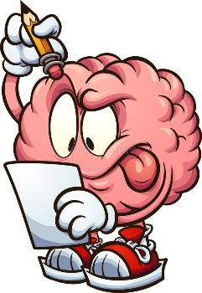
- Handling changes in routine

Executive Function Skills: Your Brain’s Management System

Executive functioning skills are the mental tools we use every day to learn, work, and solve problems. Everyone, including adults, uses these skills! The good news is that executive functioning skills can improve with practice!

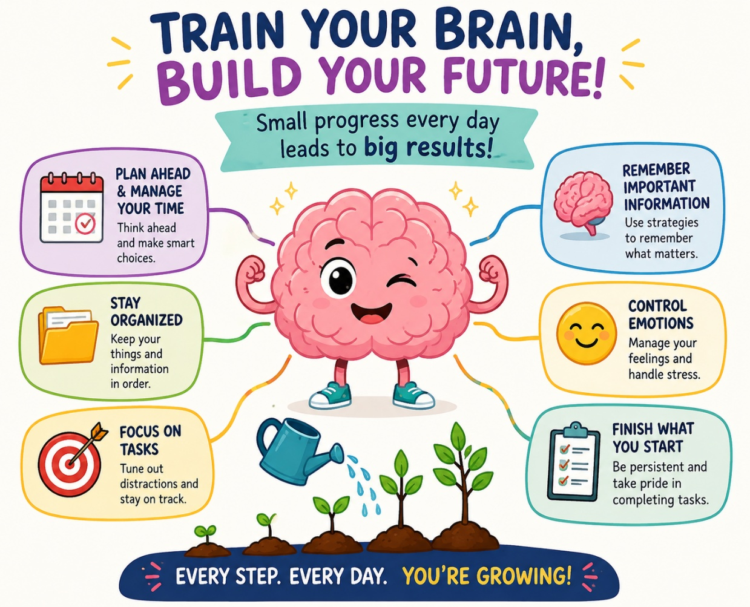

TRAIN YOUR BRAIN, BUILD YOUR FUTURE!
Small progress every day leads to big results!

Plan Ahead & Manage Your Future
Think ahead and make smart choices.

Stay Organized
Keep your things and information in order.

Focus on Tasks
Tune out distractions and stay on track.

Remember Important Information
Use strategies to remember what matters.

Control Emotions
Manage your feelings and handle stress.

Finish What You Start
Be persistent and take pride in completing tasks.

Every Step. Every Day. You're Growing!

Self-Advocacy Corner
Knowing your diagnosis and speaking up is a skill, and every time you practice, you become a stronger self-advocate. Strategies that might help...

If organization is hard...
⭐Use color-coded folders
⭐Keep a planner or digital calendar
⭐Keep your workspace/backpack clean

If remembering assignments is hard...
⭐Set phone reminders for due dates
⭐Write down tasks immediately
⭐Check your school portal daily
⭐Use a visual schedule

If getting started is hard...
⭐Use the “5-minute rule”
⭐ Tell yourself, I’ll work for just five minutes
⭐ Most times, you’ll continue working.

If you lose focus...
⭐Work for 20-25 minutes
⭐Take a short break then return to work
⭐Find a quiet workplace
⭐Use checklists
The more you understand yourself, the more prepared you'll be for adulthood!

🗣 I learn best when__________________________________________.
🗣 One accommodation that helps me is_________________________.
🗣 If I need help, I can say_____________________________________.

